11 June 2020

|  |  |  |  |
| --- | --- | --- | --- |
| Date: | 11 June 2020 | Name: | Srinidhi J C |
| Course: | VLSI | USN: | 4al16ec078 |
| Topic: | CMOS Inverter Basics | Semester & Section: | 8th & b |
| Github Repository: | SrinidhiJC078 |  |  |

|  |
| --- |
| FORENOON SESSION DETAILS |
| Image of session |
| Report –  CMOS Inverters:  A simple description of the characteristics of CMOS inverters by Bruce Sales  **Introduction:** CMOS inverters (Complementary NOSFET Inverters) are some of the most widely used and adaptable MOSFET inverters used in chip design. They operate with very little power loss and at relatively high speed. Furthermore, the CMOS inverter has good logic buffer characteristics, in that, its noise margins in both low and high states are large.  This short description of CMOS inverters gives a basic understanding of the how a CMOS inverter works. It will cover input/output characteristics, MOSFET states at different input voltages, and power losses due to electrical current.  A CMOS inverter contains a PMOS and a NMOS transistor connected at the drain and gate terminals, a supply voltage VDD at the PMOS source terminal, and a ground connected at the NMOS source terminal, were VIN is connected to the gate terminals and VOUT is connected to the drain terminals.(See diagram). It is important to notice that the CMOS does not contain any resistors, which makes it more power efficient that a regular resistor-MOSFET inverter.As the voltage at the input of the CMOS device varies between 0 and 5 volts, the state of the NMOS and PMOS varies accordingly. If we model each transistor as a simple switch activated by VIN, the inverter’s operations can be seen very easily:    **Transistor "switch model"**  The switch model of the MOSFET transistor is defined as follows:   |  |  |  | | --- | --- | --- | | **MOSFET** | **Condition on MOSFET** | **State of MOSFET** | | NMOS | Vgs<Vtn | OFF | | NMOS | Vgs>Vtn | ON | | PMOS | Vsg<Vtp | OFF | | PMOS | Vsg>Vtp | ON |   When VIN is low, the NMOS is "off", while the PMOS stays "on": instantly charging VOUT to logic high. When Vin is high, the NMOS is "on and the PMOS is "on: draining the voltage at VOUT to logic low.  This model of the CMOS inverter helps to describe the inverter conceptually, but does not accurately describe the voltage transfer characteristics to any extent. A more full description employs more calculations and more device states.  **Multiple state transistor model**  The multiple state transistor model is a very accurate way to model the CMOS inverter. It reduces the states of the MOSFET into three modes of operation: Cut-Off, Linear, and Saturated: each of which have a different dependence on Vgs and Vds. The formulas which govern the state and the current in that given state is given by the following tabel:   |  |  |  |  | | --- | --- | --- | --- | | NMOS Characteristics |  |  |  | |  | Condition on *VGS* | Condition on *VDS* | Mode of Operation | |  |  |  |  | | *ID* = 0 | *VGS* < *VTN* | All | Cut-off | |  |  |  |  | | *ID* = *kN* [2(*VGS* - *VTN* ) *VDS* - *VDS*2 ] | *VGS* > *VTN* | *VDS* < *VGS* -*VTN* | Linear | |  |  |  |  | | *ID* = *kN* (*VGS* - *VTN* )2 | *VGS* > *VTN* | *VDS* > *VGS* -*VTN* | Saturated | |  |  |  |  | |  |  |  |  | | PMOS Characteristics |  |  |  | |  | Condition on *VSG* | Condition on *VSD* | Mode of Operation | |  |  |  |  | | *ID* = 0 | *VSG* < -*VTP* | All | Cut-off | |  |  |  |  | | *ID* = *kP* [2(*VSG* + *VTP* ) *VSD* - *VSD*2 ] | *VSG* > -*VTP* | *VSD* < *VSG* +*VTP* | Linear | |  |  |  |  | | *ID* = *kP* (*VSG* + *VTP* )2 | *VSG* > -*VTP* | *VSD* > *VSG* +*VTP* | Saturated | |  |  |  |  |   In order to simplify calculations, I have made use of an internet circuit simulation device called "MoHAT." This tool allows the user to simulate circuits containing a few transistors in a simple and visually appealing way. The circuits shown below show the state of each transistor (black for cut-off, red for linear, and green for saturation) accompanied by the voltage transfer characteristic curve (VOUT vs. VIN). The vertical line plotted on the VTC corresponds to the value of VIN on the circuit diagram. The following series of diagrams depict the CMOS inverter in varying input voltages ranging from low to high in ascending order.   |  |  |  | | --- | --- | --- | |  | **Table of figures** |  | | figure | mode of operation | Logic output level | | 1 | VIN < VIL | High | | 2 | VIN < VIL | High | | 3 | VIL < VIN <VIH | <undetermined> | | 4 | VIN > VIH | Low | | 5 | VIN > VIH | Low |           **Power dissapation analysis of CMOS inverter**  As I mentioned before, the CMOS inverter shows very low power dissipation when in proper operation. In fact, the power dissipation is virtually zero when operating close to VOH and VOL. The following graph shows the drain to source current (effectively the overall current of the inverter) of the NMOS as a function of input voltage. Note that the current in the far left and right regions (low and high VIN respectively) have low current, and the peak current in the middle is only .232mA (a 1.16mW power dissipation).    **Conclusion**  The CMOS inverter is an important circuit device that provides quick transition time, high buffer margins, and low power dissipation: all three of these are desired qualities in inverters for most circuit design. It is quite clear why this inverter has become as popular as it is. |

|  |  |  |  |  |
| --- | --- | --- | --- | --- |
| Date: | 11 June 2020 | Name: | Srinidhi J C | |
| Course: | IOT in Python with Rosberry Pi | USN: | 4al16ec078 | |
| Topic: | Sensors, Actuators & Protocols | Semester & Section: | 8th & b | |
| AFTERNOON SESSION DETAILS | | | |
| Image of session | | | |

Report:

In an Internet of Things (IoT) ecosystem, two things are very important: the Internet and physical devices like sensors and actuators. As shown in Fig. 1, the bottom layer of the IoT system consists of sensor connectivity and network to collect information. This layer is an essential part of the IoT system and has network connectivity to the next layer, which is the gateway and network layer.

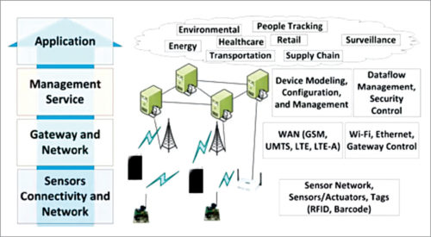

Fig.: IoT architecture layers

The main purpose of sensors is to collect data from the surrounding environment. Sensors, or ‘things’ of the IoT system, form the front end. These are connected directly or indirectly to IoT networks after signal conversion and processing. But all sensors are not the same and different IoT applications require different types of sensors. For instance, digital sensors are straightforward and easy to interface with a microcontroller using Serial Peripheral Interface (SPI) bus. But for analogue sensors, either analogue-to-digital converter (ADC) or Sigma-Delta modulator is used to convert the data into SPI output.

## Some common types of IoT sensors

### Temperature sensors

These devices measure the amount of heat energy generated from an object or surrounding area. They find application in air-conditioners, refrigerators and similar devices used for environmental control. They are also used in manufacturing processes, agriculture and health industry.

Temperature sensors can be used almost in every IoT environment, from manufacturing to agriculture. In manufacturing, sensors are used to monitor the temperature of machines. In agriculture, these can be used to monitor the temperature of soil, water and plants.

Temperature sensors include thermocouples, thermistors, resistor temperature detectors (RTDs) and integrated circuits (ICs). Some common types of temperature sensors are shown in Fig. 2.

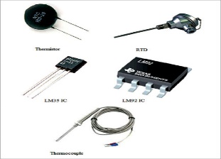

Fig.: Temperature sensors

### [Humidity sensors](https://www.electronicsforu.com/resources/electronics-components/humidity-sensor-basic-usage-parameter)

The amount of water vapour in air, or humidity, can affect human comfort as well as many manufacturing processes in industries. So monitoring humidity level is important. Most commonly used units for humidity measurement are relative humidity (RH), dew/frost point (D/F PT) and parts per million (PPM).

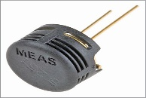

Fig.: HPP801A031 humidity sensor

### Motion sensors

Motion sensors are not only used for security purposes but also in automatic door controls, automatic parking systems, automated sinks, automated toilet flushers, hand dryers, energy management systems, etc. You use these sensors in the IoT and monitor them from your smartphone or computer. HC-SR501 passive infrared (PIR) sensor is a popular motion sensor for hobby projects.

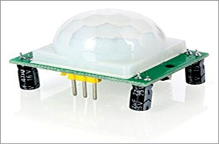

Fig.: PIR motion sensor

### Gas sensors

These sensors are used to detect toxic gases. The sensing technologies most commonly used are electrochemical, photo-ionisation and semiconductor. With technical advancements and new specifications, there are a multitude of gas sensors available to help extend the wired and wireless connectivity deployed in IoT applications.

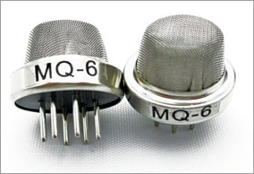

Fig.: Gas sensors

### Smoke sensors

Smoke detectors have been in use in homes and industries for quite a long time. With the advent of the IoT, their application has become more convenient and user-friendly. Furthermore, adding a wireless connection to smoke detectors enables additional features that increase safety and convenience.

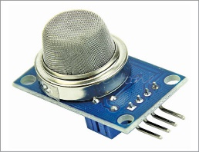

Fig.: Arduino-compatible smoke sensor

### [Pressure sensors](https://www.electronicsforu.com/resources/learn-electronics/pressure-sensors-market)

These sensors are used in IoT systems to monitor systems and devices that are driven by pressure signals. When the pressure range is beyond the threshold level, the device alerts the user about the problems that should be fixed. For example, BMP180 is a popular digital pressure sensor for use in mobile phones, PDAs, GPS navigation devices and outdoor equipment. Pressure sensors are also used in smart vehicles and aircrafts to determine force and altitude, respectively. In vehicle, tyre pressure monitoring system (TPMS) is used to alert the driver when tyre pressure is too low and could create unsafe driving conditions.

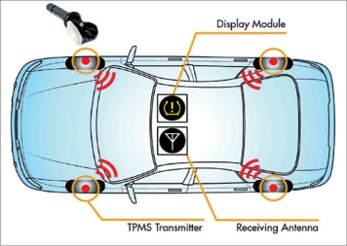

Fig.: Overview of TPMS (Courtesy: www.mwrf.com)

### Image sensors

These sensors are found in digital cameras, medical imaging systems, night-vision equipment, thermal imaging devices, radars, sonars, media house and biometric systems. In the retail industry, these sensors are used to monitor customers visiting the store through IoT network. In offices and corporate buildings, they are used to monitor employees and various activities through IoT networks.

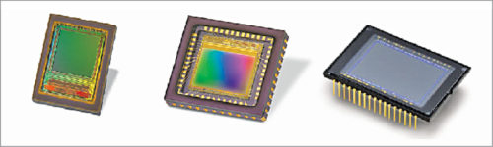

Fig.: Different types of image sensors

### [Accelerometer sensors](https://www.electronicsforu.com/resources/learn-electronics/accelerometer-tilt-sensor)

These sensors are used in smartphones, vehicles, aircrafts and other applications to detect orientation of an object, shake, tap, tilt, motion, positioning, shock or vibration. Different types of accelerometers include Hall-effect accelerometers, capacitive accelerometers and piezoelectric accelerometers.

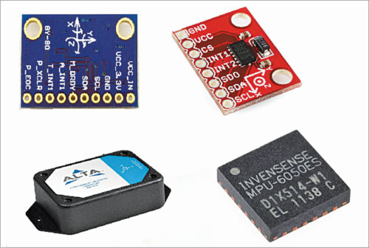

Fig.: Various types of accelerometer sensors

### IR sensors

These sensors can measure the heat emitted by objects. They are used in various IoT projects including healthcare to monitor blood flow and blood pressure, smartphones to use as remote control and other functions, wearable devices to detect amount of light, thermometers to monitor temperature and blind-spot detection in vehicles.

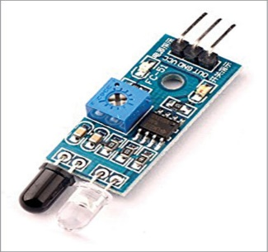

Fig.: IR sensor

### Proximity sensors

These sensors detect the presence or absence of a nearby object without any physical contact. Different types of proximity sensors are inductive, capacitive, photoelectric, ultrasonic and magnetic. These are mostly used in object counters, process monitoring and control.

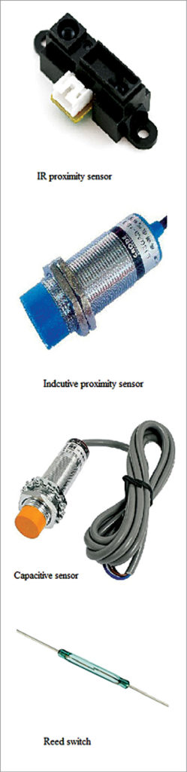

Fig.: Various proximity sensors

Protocols:

HTTP: Hypertext transfer protocol or HTTP is a fundamental protocol used on the Internet to control data transfer to and from a hosting server, in communication with a web browser. HTTP is the essential means of communication between web users and the servers that maintain the websites themselves.

MQTT: MQTT is a machine-to-machine (M2M)/"Internet of Things" connectivity protocol. It was designed as an extremely lightweight publish/subscribe messaging transport. It is useful for connections with remote locations where a small code footprint is required and/or network bandwidth is at a premium. For example, it has been used in sensors communicating to a broker via satellite link, over occasional dial-up connections with healthcare providers, and in a range of home automation and small device scenarios. It is also ideal for mobile applications because of its small size, low power usage, minimised data packets, and efficient distribution of information to one or many receivers.

Web-sockets: WebSocket is a computer communications protocol, providing full-duplex communication channels over a single TCP connection. The WebSocket protocol was standardized by the IETF as RFC 6455 in 2011, and the WebSocket API in Web IDL is being standardized by the W3C.

CoAP: “The Constrained Application Protocol (CoAP) is a specialized web transfer protocol for use with constrained nodes and constrained networks in the **Internet of Things.** The protocol is designed for machine-to-machine (M2M) applications such as smart energy and building automation.”